
CpE-371: SOFTWARE ENGINEERING AND DEVELOPMENT

<AMA-PLATFORM>
Software Requirements Specification (SRS)

Version | v0.1
Status | Final
Date | 17-10-2026
Prepared by | Abdulrahman Bin Bahar, 2221130212

Department of Computer Engineering
College of Engineering and Petroleum
Kuwait University
20xx - 20xx

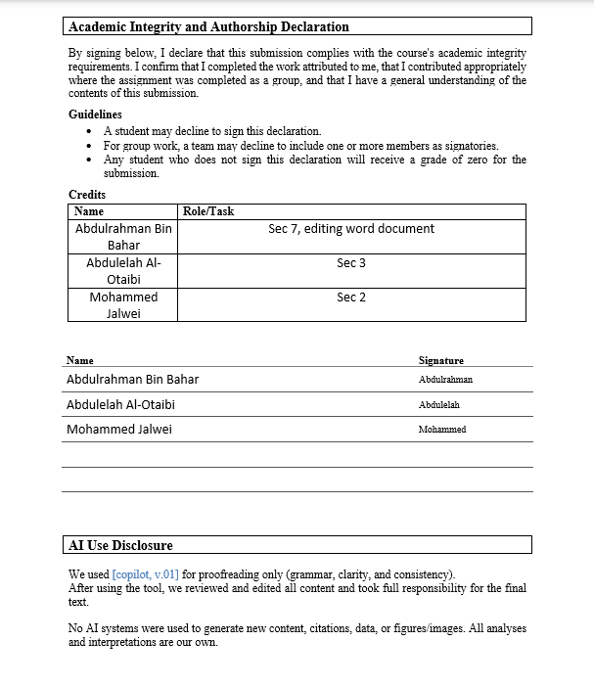

Signature Page

I did my share of the work, and I have a general understanding of the contents of the assignment
Name Signature
Abdulrahman Bin Bahar Abdulrahman
Abdulelah Al-Otaibi Abdulelah
Mohammed Galwei Mohammed

Report Evaluation
Criterion | Evidence / focus | Weight | Marks | Comments
Document control & professionalism | Version history, ownership, formatting, completeness | 5
Introduction & project framing | Purpose, scope, vision, constraints, assumptions, stakeholders | 10
Functional requirements | Clear, grouped, numbered, testable 'shall' statements | 15
Use-case model | Diagram, actors, use-case specs, traceability, coverage | 15
Non-functional requirements | Measurable NFRs with verification method | 10
Domain / data model | Domain overview, ERD/model, retention/deletion/auditability | 10
UI prototype & usability | Scenario coverage, key screens, findings, updates | 10
Project management & evidence | WBS, Gantt, refs, repo links, meeting records | 5
Team Deliverable Quality (Total) |  |  |  | out of 80
Individual Grade (20%)
Student name | Avg peer score  (/28) | Adjustment | Final mark  (/100) | Notes

Table of Contents
Contents
1
1. Document Control 6
1.1 Version history 6
1.2 Credits 7
1.3 Related documents / links 7
2.1 Purpose 7
2.2 Product vision 7
2.3 Scope 7
2.4 Assumptions and dependencies 8
2.5 Constraints 8
2.6 Stakeholder summary 8
2.7 Overview 8
3. Functional Requirements and Use-case Model 9
3.1 Functional requirements 9
3.2 Use Case Model 10
4. Non-functional Requirements 12
5. Domain overview 12
5.2 Entity-relationship diagram (ERD) / domain model 13
5.3 Data retention, deletion, and auditability 13
6. UI Prototype and Usability Evaluation 13
6.1 Prototype link(s) 13
6.2 Key screens and states 13
6.3 Usability evaluation 14
7. Appendix 15
7.1 References 15
7.2 Project Management 15
Work Breakdown Structure 15
Gantt Chart 16
Team Meetings 16

List of Abbreviations
Abbreviation | Meaning
WBS | Work Breakdown Structure
UC | Use Case
FR | Functional Requirement
SRS | Software Requirements Specification
ERD | Entity-Relationship Diagram
UI | User Interface
NFR | Non-functional Requirement
KPI | Key Performance Indicator

Glossary
Student | A user who is searching for a suitable tutor and requests a tutoring session.
availability | The time slots of the tutor’s when he is available and giving sessions.
tutor | A user who his job is to provide a tutoring session.
Coordinator | A user who is responsible for coordinating between student and tutor and he is the one who manages bookings.
Booking | A tutoring session that has been scheduled and confirmed.

1. Document Control

1.1 Version history
Version | Date | Author | Change summary | Approval
0.1 | 17-10-2026 | Abdulrahman | WBS, and Gantt chart | Pending
0.4 | 17-10-2026 | Abdulelah | Functional requirements, use cases | Pending
0.7 | 17-10-2026 | Mohammed | Assumptions and dependencies, constraints | Pending
1.0 | 17-10-2026 | Team | Approved release | Approved by team

1.2 Credits
Name | Role/Task
Abdulrahman | Section 7, word document
Abdulelah | Section 3
Mohammed | Sections 2

1.3 Related documents / links
- https://github.com/bhr992/Group-project.git
2. Introduction

2.1 Purpose
This SRS describes the requirements and scope of our platform. It can help and guide the stakeholders, testers, developers, and anyone who can participate in it during system development. It can ensure that all parties have the same understanding of the system.

2.2 Product vision
Our vision is to develop a software system application that helps university students who struggle with subjects or topics to find qualified Tutors who can help them understand these subjects and prepare for exams, assignments, and projects. The system aims to make it easier for students to find suitable tutoring support based on the subject and available time, and to organize the tutoring process between students and Tutors.

2.3 Scope
In scope:
- Search availability by subject, time window, and format (online or in person).
- Create a session request containing subject, topic, time window, reason, and preferred tutor when applicable.
- Route requests to tutors and exceptions to coordinators.
- Record tutor acceptance or decline with a reason.
- Create confirmations and audit records after acceptance.
- Process reschedules and cancellation requests according to system policies.
- User login and authentication.
- Same-day session reminders.
Out of scope / non-goals:
- Multi-language support.
- One tutor for one student.
- Payment processing.
- Recorded video sessions.

Assumptions and dependencies
- Assumptions: Users (students and tutors) have valid university emails to create their accounts.
- Assumptions: Tutors are qualified for the subjects they sign up to teach.
- Dependencies: Requires a stable internet connection to send real-time requests and notifications.
- Dependencies: Relies on an external email/notification service to send session reminders.

2.5 Constraints
- Regulatory / policy constraints: We must keep student and tutor data private according to university privacy policies.
- Technology / platform constraints: The app should run smoothly on standard web browsers and mobile screens.
- Operational constraints: Maintenance or database updates should be done during off-peak hours so sessions aren't interrupted.

2.6 Stakeholder summary
Role | Primary goals | Key needs / pain points | Priority (H/M/L)
Student/seeker | Search for a suitable tutor and manage sessions. | Difficulty finding a suitable tutor. | H
Tutor | Provide tutoring services and help students. | Managing availability and student requests. | H
Coordinator / Admin | Connect students with tutors and manage tutoring bookings. | Coordinating between students and tutors. | H

2.7 Overview
The remainder of this SRS is organised as follows. Section 3 describes the functional requirements and their relationship to the use cases. Section 7 lists the references, Gantt chart, Work Breakdown Structure, and project management information.

3. Functional Requirements and Use-case Model

3.1 Functional requirements
FR-01: Search and Availability
FR-01.01: The system shall allow students to search for tutors by subject or topic name.
FR-01.02: The system shall allow students to check tutors' availability within a selected time window.
FR-01.03: The system shall allow students to search for online or in-person tutoring sessions.
FR-01.04: The system shall allow tutors to publish the subjects and available times they offer for tutoring.
FR-02: Session Request
FR-02.01: The system shall allow students to submit tutoring session requests with the subject, topic, time window and in-person/online
FR-02.02: The system shall allow students to view the status of their session requests.
FR-02.03: The system shall allow tutors to accept tutoring session requests or decline with a reason.
FR-02.04: The system shall allow the coordinator to approve or reject exception requests.
FR-02.05: The system shall keep a record of each confirmed, rescheduled, and cancelled session.
FR-02.06: The system shall allow students and tutors to request rescheduled or cancelled sessions.
FR-02.07: The system shall send students and tutors email reminder notifications on the same day as their confirmed tutoring session.
FR-02.08: The system shall allow students to join a waitlist when no suitable tutor is available and accept or decline a tutoring session when one becomes available.
FR-03: Session constraints (BR)
FR-03.01: The system shall prevent tutors from having overlapped confirmed sessions.
FR-03.02: The system shall verify that a tutor is eligible for the requested subject before accepting a session.
FR-03.03: The system shall check whether a student exceeds 5 tutoring hours within any rolling 7-day period.
FR-03.04: The system shall send requests that exceed the 5-hour limit to the coordinator for approval.
FR-03.05: The system shall reject session requests submitted less than 2 hours before the proposed start time.
FR-03.06: The system shall reject session requests with a duration shorter than 30 minutes or longer than 120 minutes.
FR-03.07: The system shall allow students, tutors, and Coordinators to log in using their registered accounts.
FR-04: Session Completion and Rating
FR-04.01: The system shall allow tutors to mark tutoring sessions as completed after the session has ended.
FR-04.02: The system shall allow students to rate tutors only after completing tutoring sessions.
FR-5: Coordinator job
FR-5.01: The system shall allow the coordinator to verify tutors for specific subjects.
FR-5.02: The system shall allow the coordinator to approve or reject policy exception requests.
FR-5.03: The system shall allow the coordinator to review disputes between students and tutors.

3.2 Use Case Model
Figure 1 presents the main actors and use cases for the sample ATA-PLATFORM. The model emphasizes three main use cases:

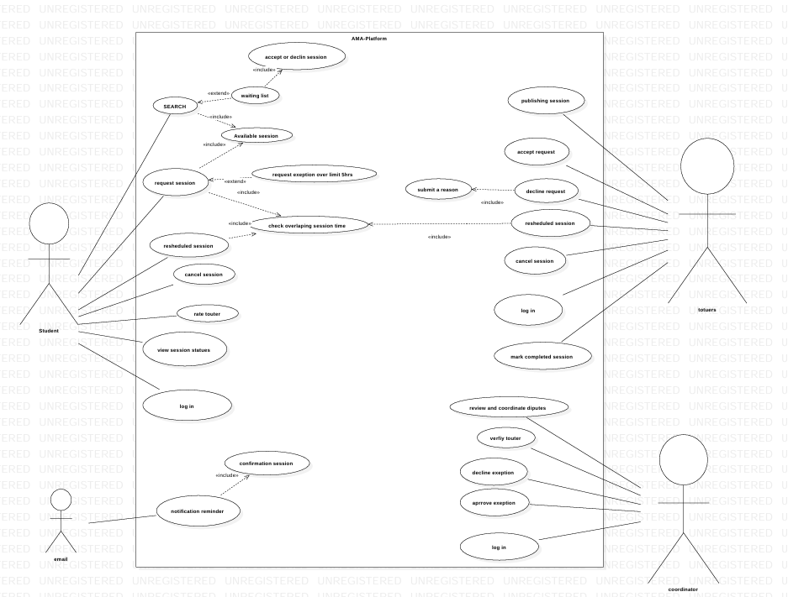
Figure 1 Use Case Diagram for ATA-PLATFORM

Use case UC- 1: Search for a tutor
Related Requirements | FR-01.01, FR-01.02, FR-01.03, FR-01.04
Description (Goal) | To let students search for a suitable tutor in the time they are suitable with
Primary Actor(s) | Student
Secondary Actor(s) | Tutor
Preconditions | The student must be logged into the system.
Post-conditions | The tutor must publish his session times
Related use cases | UC-02
Basic Flow | - Student logs into the system.  - Student search for tutors.  - The system shall display tutors.  - Tutors’ info will appear to student.
Alternative Flow | There will be no suitable tutor for the student.

Use case UC- 2: request a Session
Related Requirements | FR-02.01, FR-02.02, FR-02.05, FR-02.06, FR-02.08, FR-03.01, FR-03.02, FR-03.03, FR-03.04, FR-03.05, FR-03.06
Description (Goal) | Allow students to make a request for a tutoring session.
Primary Actor(s) | Student
Secondary Actor(s) | Tutor, coordinator
Preconditions | The student must have selected a suitable tutor.
Post-conditions | The session will be created and then sent to the tutor.
Related use cases | UC-01
Basic Flow | - The student logs into the system.  - The student searchs for a suitable tutor.  - The tutor is selected.  - The system shall send it to the tutor.  - The student will enter the session.
Alternative Flow | - The request will be rejected due to a constraint.

Use case UC- 3: reminder notification
Related Requirements | FR-02.07
Description (Goal) | Reminds students and touters of the sessions they have.
Primary Actor(s) | System.
Secondary Actor(s) | Tutor, student.
Preconditions | Confirmed session requests.
Post-conditions | The system sends notification on the day of sessions through email message.
Related use cases | none
Basic Flow | 1- system checks confirmed sessions.  2- system finds sessions day date.  3- system sends the reminder to the student and tutor.
Alternative Flow | 1- System check session due day not the current day  2- System does not send a reminder to student and touter.

4. Non-functional Requirements
Each NFR should be measurable and include a verification method (test, analysis, inspection, or monitoring).
NFR-01: [Category Name]
1.1 [Requirement title]: The system shall [measurable quality/constraint].
NFR-02: [Category Name]
2.1 [Requirement title]: The system shall [measurable quality/constraint].
NFR-03: [Category Name]
3.1 [Requirement title]: The system shall [privacy/ethical constraint].
3.2 [Requirement title]: The system shall [privacy/ethical constraint].
NFR-04: [Category Name]
4.1 [Requirement title]: The interface shall [usability condition].
NFR-05: [Category Name]
5.1 [Requirement title]: The system shall [security requirement].
5.2 [Requirement title]: The system shall [security requirement].
5.3 [Requirement title]: The system shall [access-control requirement].
NFR-06: [Category Name]
6.1 [Requirement title]: The system shall [maintainability requirement].
6.2 [Requirement title]: The system shall [maintainability requirement].

5. Domain overview
[Describe the core domain concepts and how they relate. Keep this aligned with the entity model.]

5.2 Entity-relationship diagram (ERD) / domain model
[Insert ERD/domain diagram here.]

5.3 Data retention, deletion, and auditability
- Retention: [e.g., keep audit logs for X days]
- Deletion: [e.g., GDPR delete within X days]
- Audit: [what events must be logged]

6. UI Prototype and Usability Evaluation
If the product is UI-heavy, include a prototype and a brief evaluation to reduce ambiguity and rework.
[Create a UI prototype covering a scenario for each main use case (e.g. if you have 3 main use cases, cover 3 scenarios, and so on) using Invision app. Create the screens using some proper software tool then connect them on Invision app. Make sure to show data in the scenarios (e.g. in case of a login form show it first empty then when the user clicks on it show the data filled in the fields).]
The goal of this prototype is elicit requirement from the customer using prototyping based on scenarios from the requirement specifications. This prototype is be able to handle < your number of main use cases > scenarios. It was tested on [3] users.

6.1 Prototype link(s)
- Figma / prototype: [link]

6.2 Key screens and states
[Create a prototype of your system on invision app covering the < your number of main use cases > chosen scenarios. Create the screens using proper software tools then connect them on Invision app. Make sure to show data in the scenarios. Include the invision app link here. In addition, describe your preliminary design by presenting pictures of important screens and briefly explaining the function of each screen.]
This section of the document contains brief descriptions of the main screens in <name of your application>. Each screen in the system shows the behavior and state changes that the user will experience when pressing a button or choosing an option on the screen. InVision App online prototyping tool was used to create all of the system screens. The UI interactive prototype is available online at this <your invision app link>.

- ……… Screen (e.g. Login Screen)
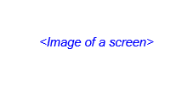
Figure 2 .... Screen
Description: …………………………………………………………………..

- ……… Screen

Figure 3 ..... Screen
Description: …………………………………………………………………..

6.3 Usability evaluation
Scenario ID | Scenario | Participants | Findings | Action / requirement update
UE-0X | [User tries to …] | [N users, profile] | [What worked / what failed] | [Change to story/NFR/UI]
UE-0X | [User tries to …] | [N users, profile] | [What worked / what failed] | [Change to story/NFR/UI]
UE-0X | [User tries to …] | [N users, profile] | [What worked / what failed] | [Change to story/NFR/UI]
UE-0X | [User tries to …] | [N users, profile] | [What worked / what failed] | [Change to story/NFR/UI]

7. Appendix

7.1 References
- Course notes, lecture slides, and instructor feedback for CpE-371 Software Engineering and Development.

7.2 Project Management

Work Breakdown Structure
ID | Task name | Duration | Start | Finish | Pred. | Resources
1 | Project proposal | 4 d | 2026-10-16 | 2026-10-21 | - | Team
2 | Requirements elicitation | 6 d | 2026-10-16 | 2026-10-21 | 1 | Mohammed, Abdulelah
3 | SRS drafting | 8 d | 2026-10-22 | 2026-11-16 | 2 | Team
4 | Use case and domain modeling | 6 d | 2026-10-22 | 2026-10-27 | 2 | Abdulelah
5 | UI prototyping | 7 d | 2026-10-28 | 2026-11-03 | 3,4 | Team
6 | Usability testing | 4 d | 2026-11-04 | 2026-11-07 | 5 | Team
7 | Design revision | 4 d | 2026-11-08 | 2026-11-11 | 6 | Team
8 | Implementation planning | 5 d | 2026-11-12 | 2026-11-16 | 7 | Abdulrahman
9 | Final review & submission | 5 d | 2026-11-16 | 2026-11-16 | 8 | Team

Gantt Chart
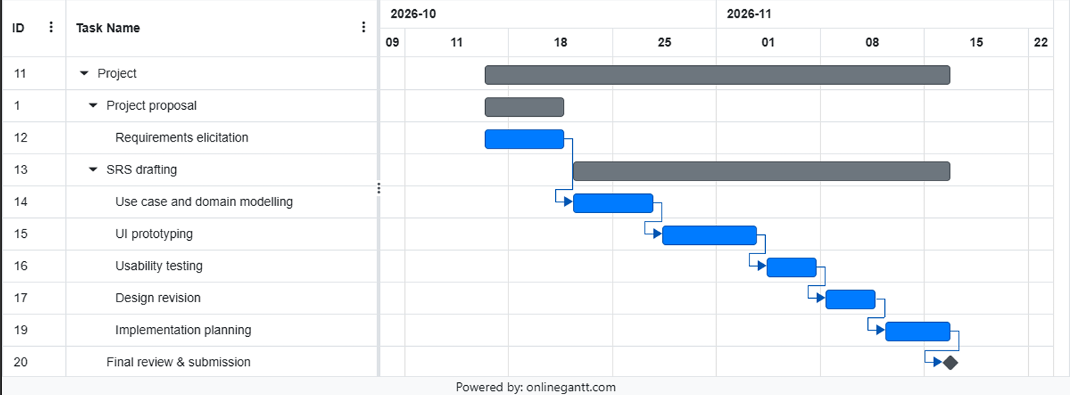
Repository link: https://github.com/bhr992/Group-project.git

Team Meetings
Meeting | Date | Attendees | Main outcome | Minutes link
M1 | 2026-02-03 | All team members | Confirmed project scope, stakeholder list, and initial assumptions. | https://github.com/bhr992/Group-project.git
M2 | 2026-02-11 | All team members | Reviewed functional requirements and main use cases, create the chart | https://github.com/bhr992/Group-project.git

